
AMERICAN INTERNATIONAL UNIVERSITY-BANGLADESH (AIUB)
Department of CSE
Computer Aided Design and Drafting

Section: L
Experiment No: # 04
Name: Khan, Md. Sazzad
Id: 22–49172-3
Supervised by: MD. RAKIBUL ISLAM CHOWDHURY

Name of Experiment: Familiarization with different isometric projections and drawing using AutoCAD software

AutoCAD Comments:

- How To go to 3D In AutoCAD :

View >> 3D Views >> SW Isometric ---
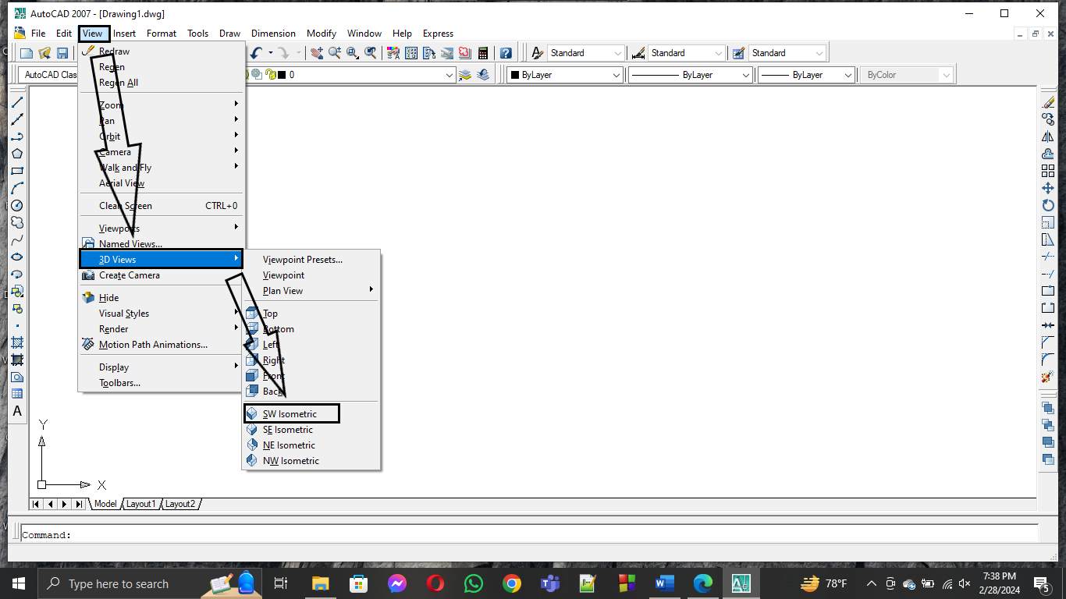
- How To Go To a Realistic View In AutoCAD :

View >> Visual Styles >> Conceptual ---

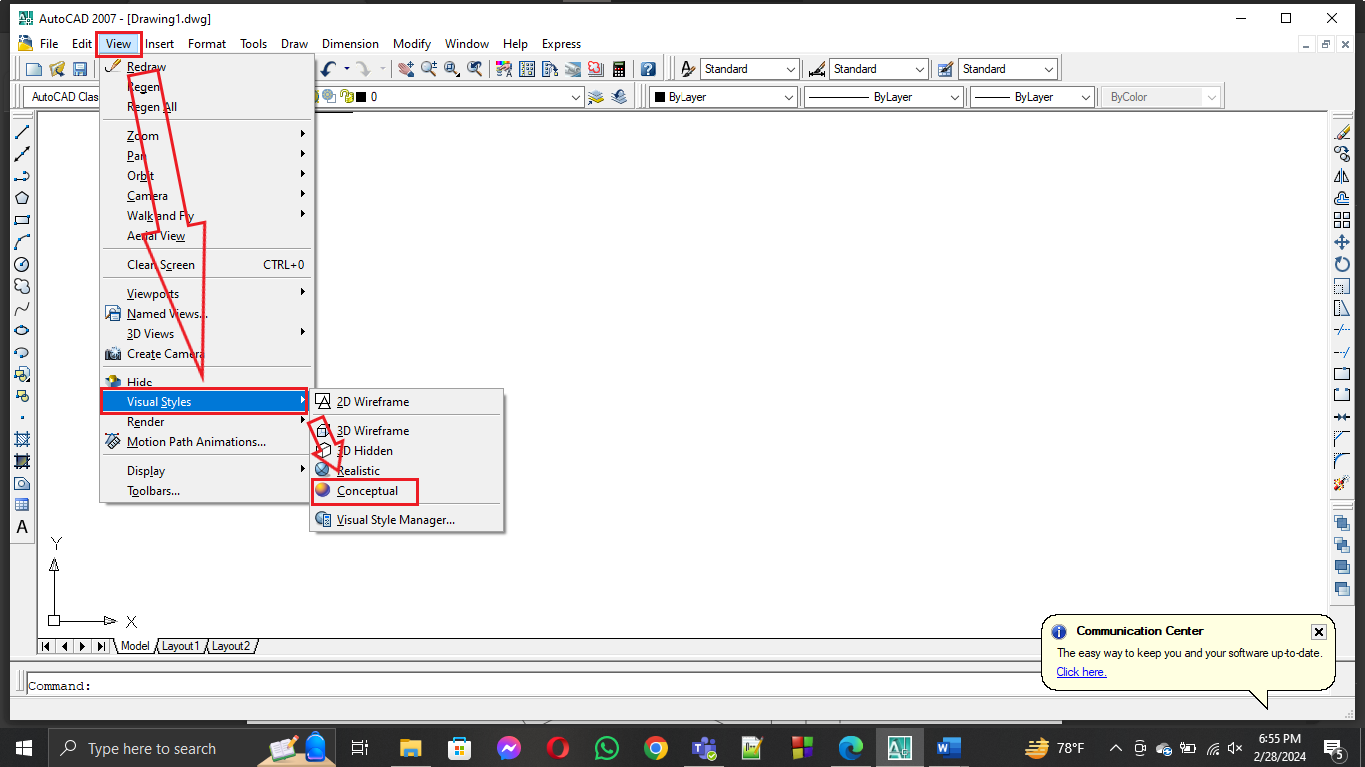

- How To go to Top View In AutoCAD :

View >> 3D Views >> Top ---

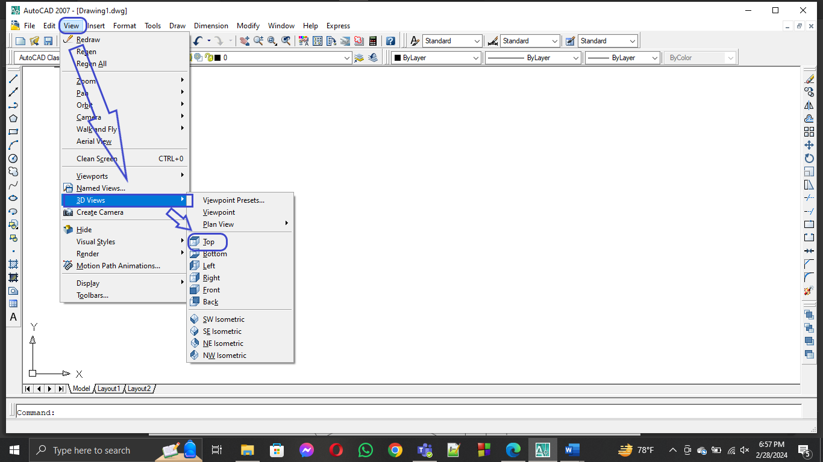

- How To Go To 2D View In AutoCAD :

View >> Visual Styles >> 2D Wireframe ---

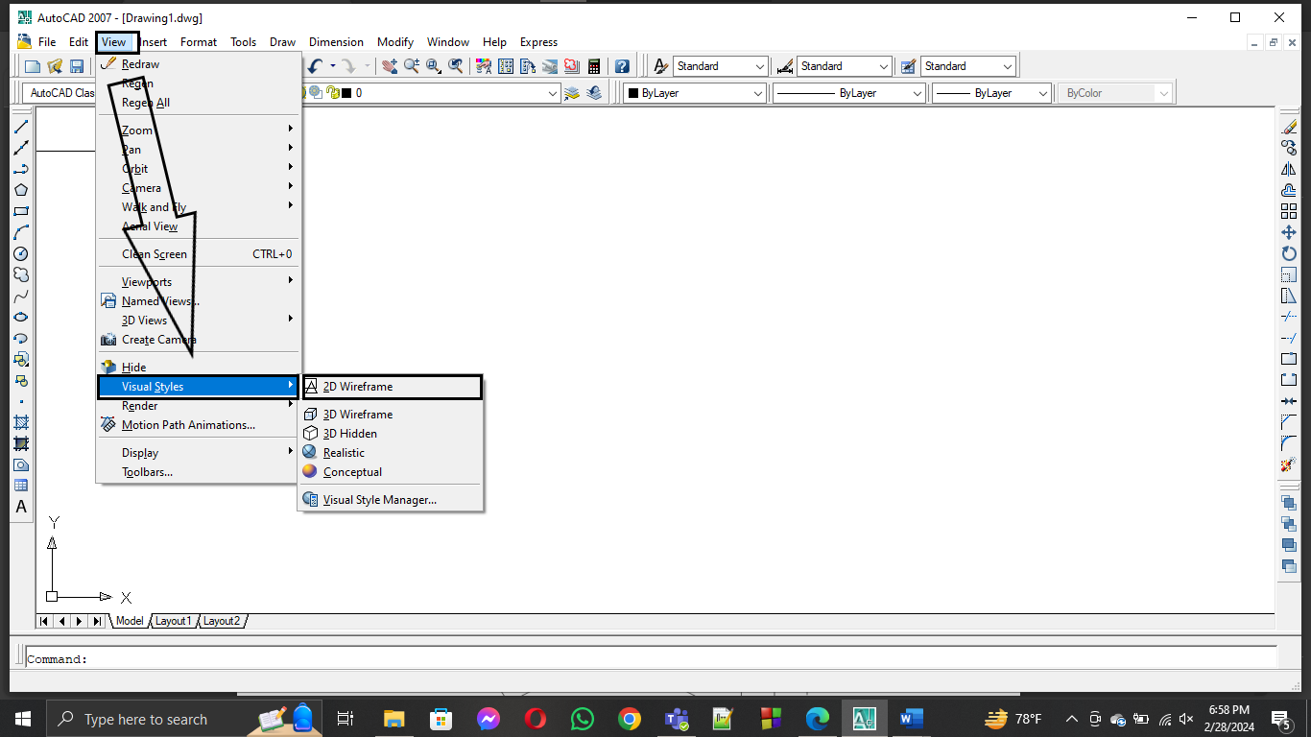

- How Rotate UCS In AutoCAD :

Tools >> New UCS >> Select the axis of rotation >> Enter the value
of rotation >> Enter

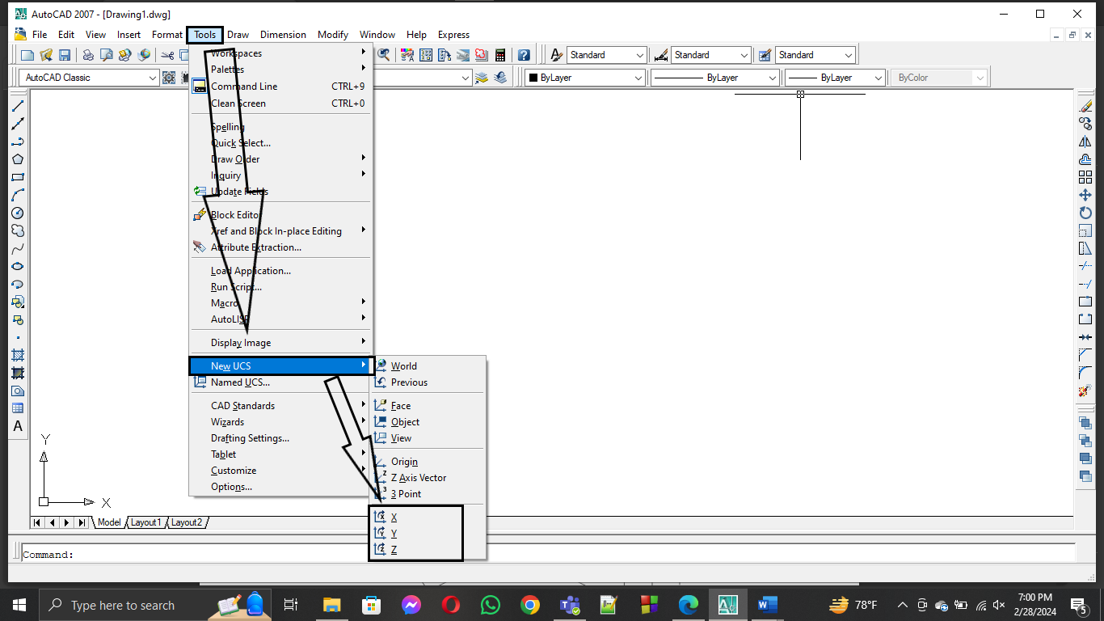

- How To Take Vertical Distance In AutoCAD :

First Rotate the UCS in such direction that x and y axis lies in
That direction in which want to measure the distance

Then ---

Tools >> New UCS >> Select Face >> Accept or Rotate the axis
>> Enter

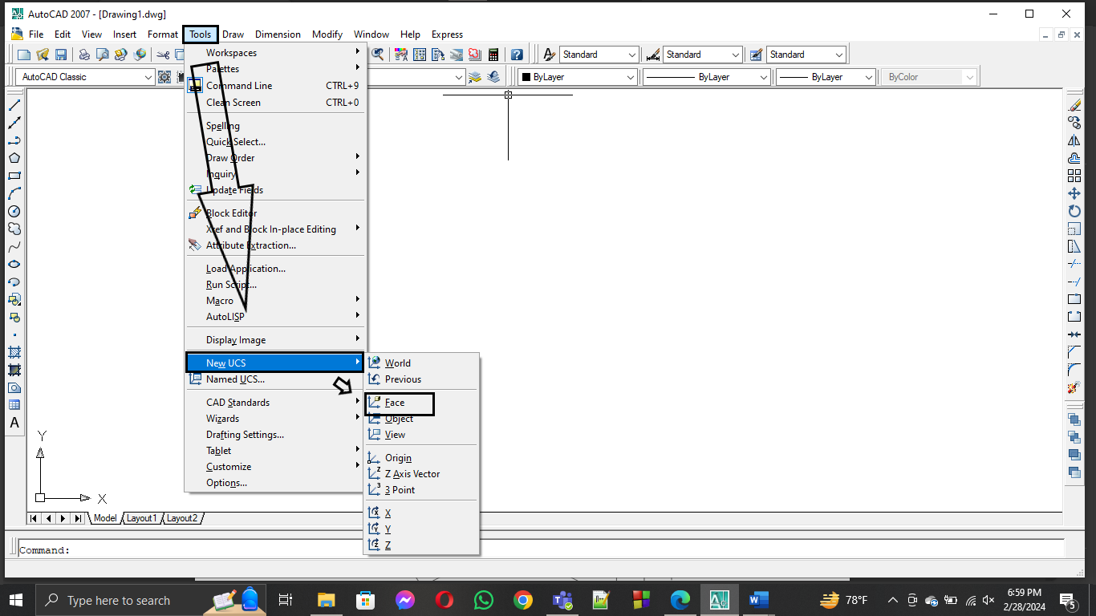

- How To Draw 3D In AutoCAD :

Presspull >> Click on the Region that want to pull >> input
vertical Distance >> enter.

- How To Merge Two or More 3D Drawing In AutoCAD:

Union >> select objects >> enter

- How Off set In AutoCAD: O >> enter >> input Distance >> enter >> select object or objects >> click on the side where want to offset >> enter

